Subject: Live virtual event 4/9: Helping kids and families thrive during extended flexible learning
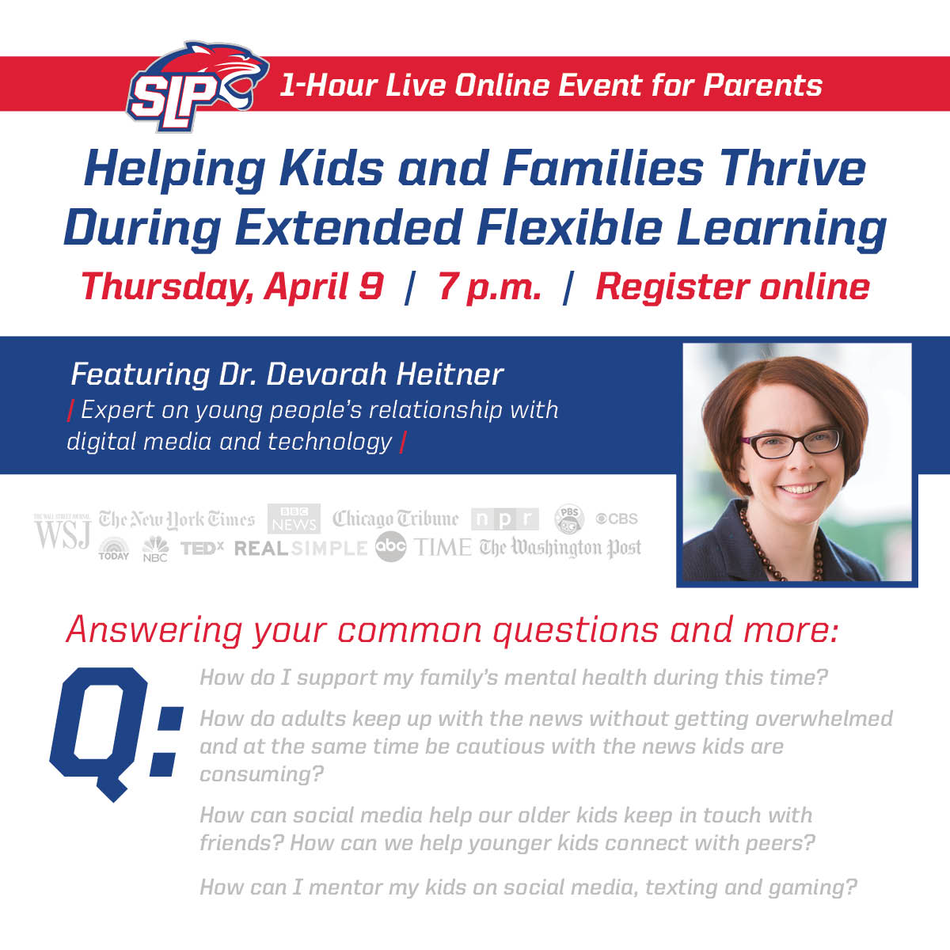
Spring Lake Park Schools Families are invited to join us for a special online event Thursday, April 9, 2020 at 7 p.m.
On March 30, school life changed as extended flexible learning began across the state. Students, teachers and families are all at home, trying to learn and work simultaneously. It is a stressful and uncertain time, however, there are important things we can do to support each other. Spring Lake Park Schools is sponsoring an online event for parents featuring Dr. Devorah Heitner, an expert on young people’s relationship with digital media and technology. In an hour-long virtual event, Dr. Heitner will provide tools and strategies to parents to address:
- How to support kids' and families' mental health during this stressful time
- How adults can keep up with the news without getting overwhelmed and at the same time be cautious with the news kids are consuming
- How social media can help older kids keep in touch with friends and to help younger kids connect with peers
- How parents can mentor kids on social media, texting, and gaming during this time

Join us Thursday, April 9, 2020, 7 p.m.
- Click here to register online
Please register by noon on Thursday, April 9. A link to join the event via Zoom video conferencing will be sent to those who register on Thursday afternoon.
About Dr. Devorah Heitner
An expert on young people’s relationship with digital media and technology, Dr. Devorah Heitner is the author of Screenwise: Helping Kids Thrive (and Survive) in Their Digital World and founder of Raising Digital Natives. Her mission is to cultivate a culture of empathy and social/emotional literacy. Dr. Heitner’s work has appeared in the New York Times, the Washington Post, The Wall Street Journal, TIME magazine and Education Week. She has a Ph.D. in Media/Technology & Society from Northwestern University and has taught at DePaul and Northwestern. She is delighted to be raising her own digital native.

